2017 OSU Turf Field Day

Thursday – August 31, 2017
Lewis-Brown Farm
3329 Peoria Rd
Corvallis, OR 97333

Schedule
8:00 am to 9:00 am – Check-in and Breakfast
9:00 am to 11:30 am - Field Day, Industry Expo
11:30 am to 12:30 pm – Lunch
1:00 pm to 7:00 pm – J. Oliver Memorial Golf Tournament and Dinner

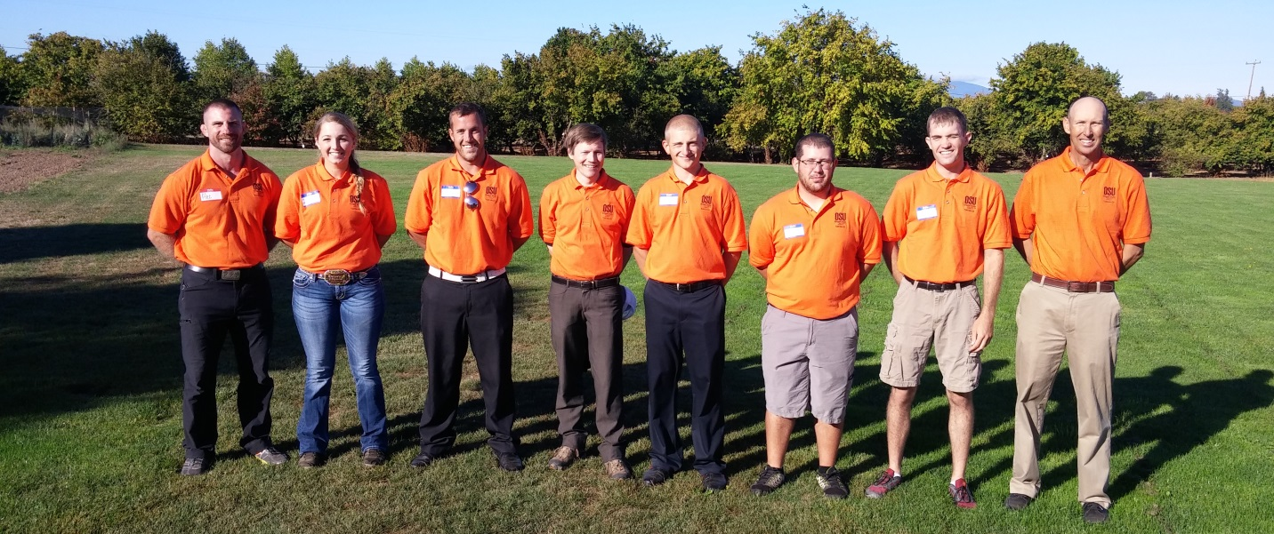

Field Day Topics
- Fungicide Alternatives for Microdochium
- Low Maintenance Ground Cover for Oregon Schools
- Greywater Use on Perennial Ryegrass
- Irrigation Rates and Frequency for Perennial Ryegrass
- Wetting Agents
- Fine Fescue NTEP Trial Updates
- Perennial Ryegrass NTEP Trial Updates
- Cool-season Low Maintenance NTEP Trial Updates
- Fungicides for Management of Anthracnose
- Broadleaf Herbicide Trial Updates
Full Package: Registration $90.00 (Due Aug 17). Onsite registration $115.
Registration includes breakfast, field day, lunch, golf and dinner.

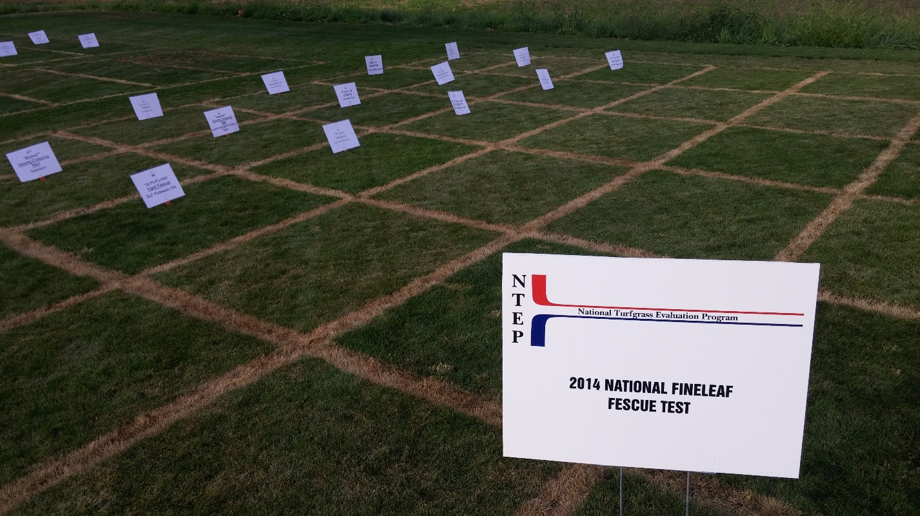

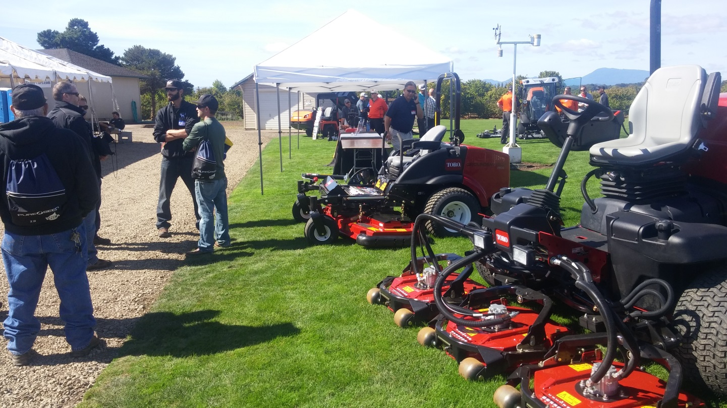

Field Day Only: Registration $60.00 (Due Aug 17). Include field day and lunch, excludes golf and dinner.
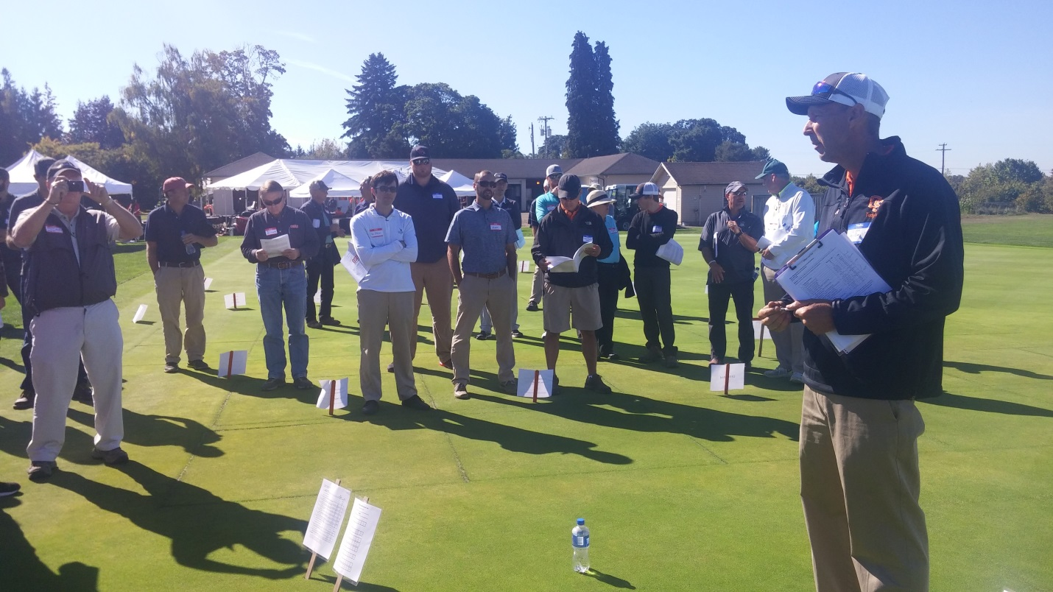
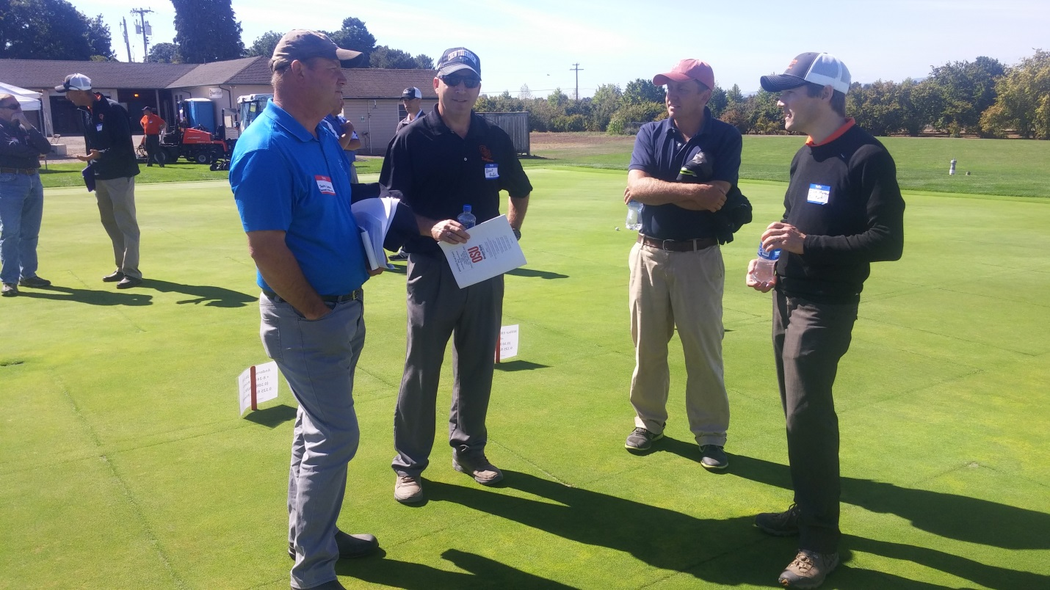

Social Package: $35.00
Lunch at Lewis-Brown Farm, or Dinner at Trysting Tree Golf Course (Due Aug 17).

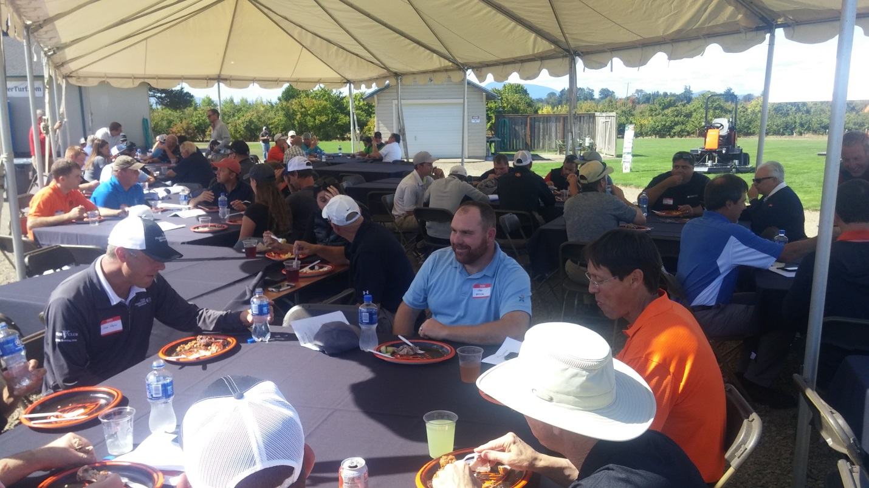

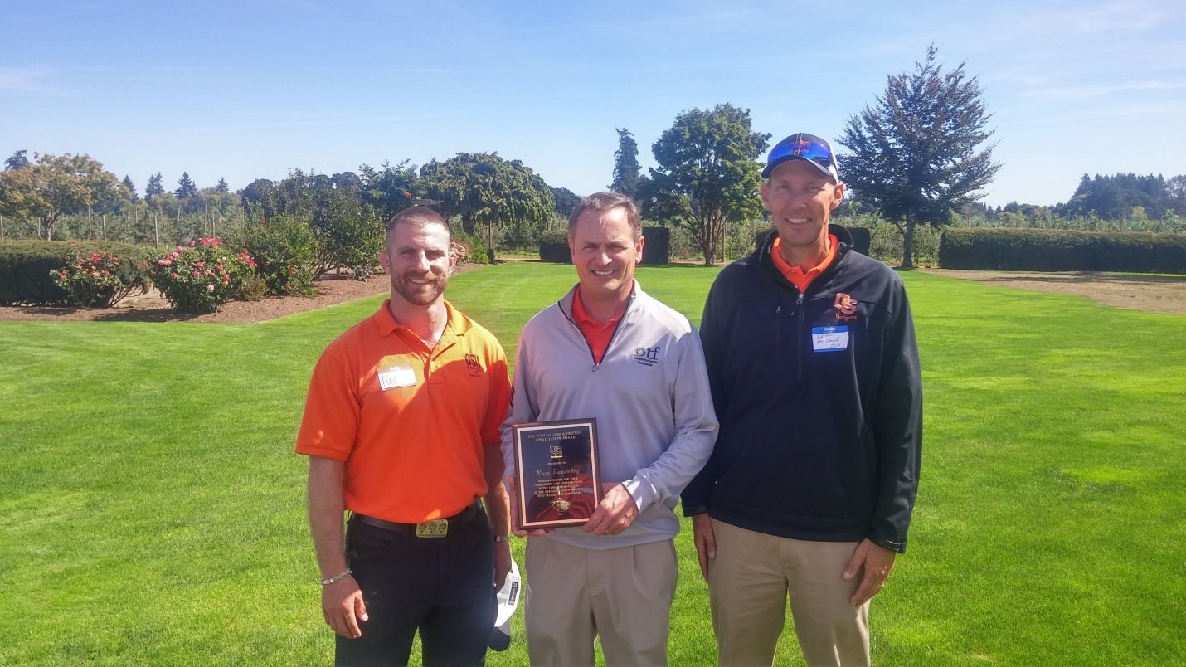

Industry Booth or Equipment Exhibitor: $90 (Due Aug 17).
Booth hours 9:00 am to 11:30 am at Lewis-Brown Turf Farm. Includes folding table (6’ x 2.5‘) and registration for 1 person (breakfast, field day, lunch, golf and dinner). Recognition in mailing/email to OGCSA, OSTMA and OLCA members.

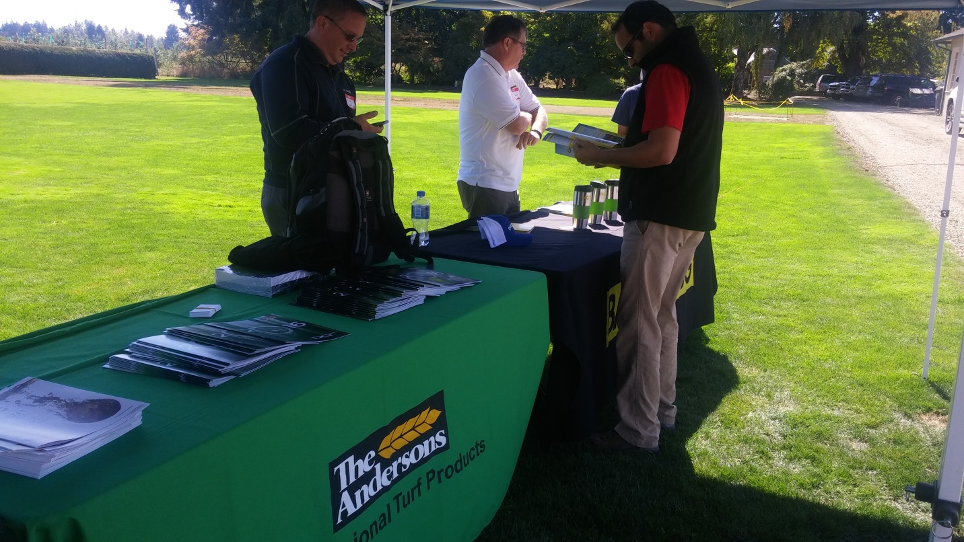

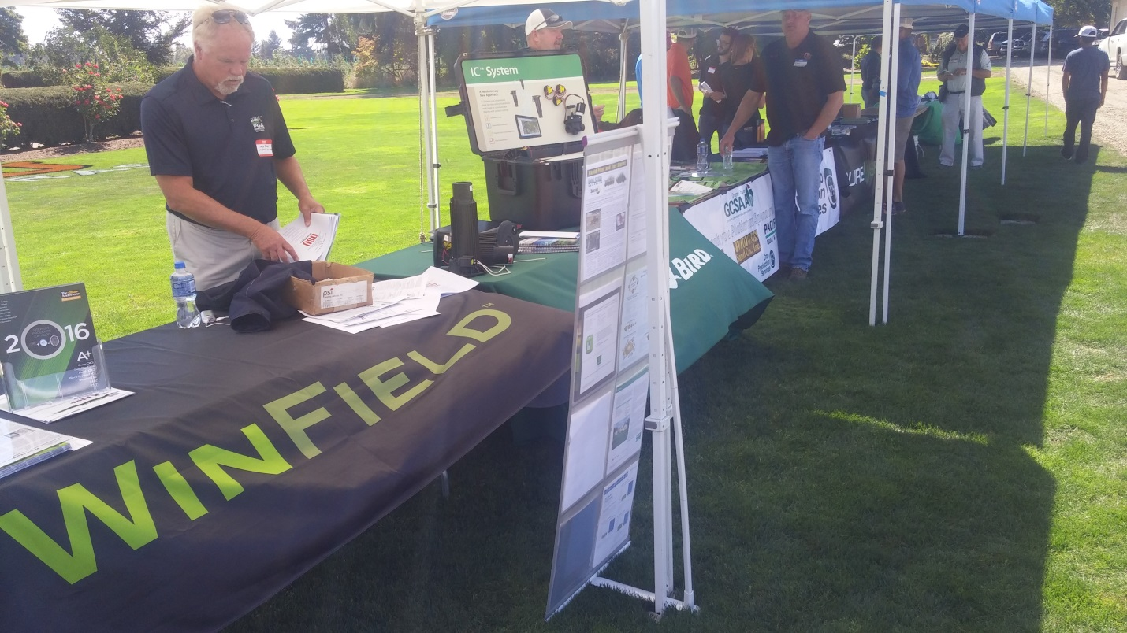

Golf Outing Tee Sponsor: $250
Includes golf outing tee sponsor sign, recognition in mailing/email to OGCSA, OSTMA, OLCA members, recognition on the OSU Turf website and recognition at the OSU Turf Field Day

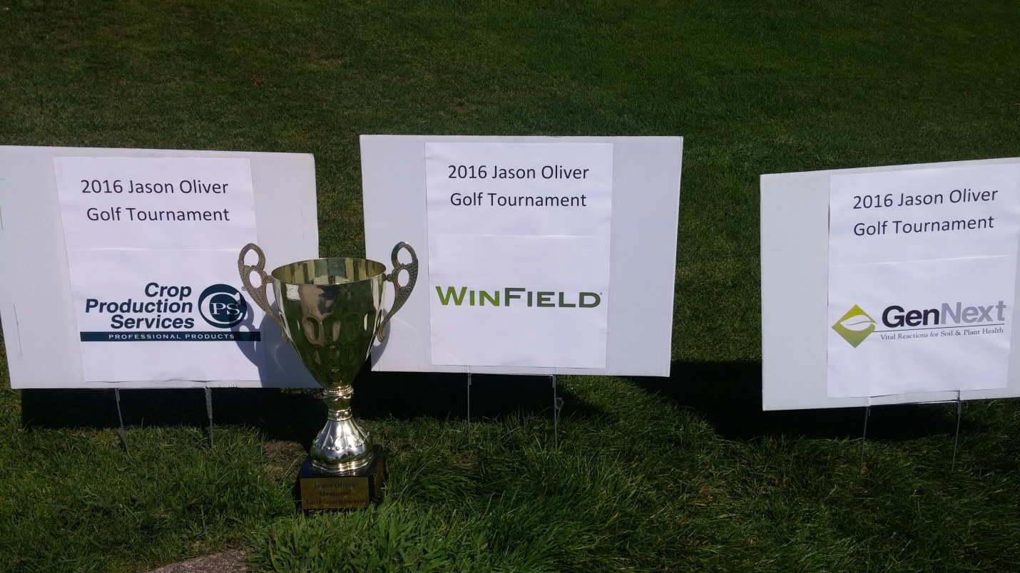

---------------------------- Registration ---------------------------------
Select a Package | Number | Total
Full Package ($90) |  | $
Field Day and Lunch ($60) |  | $
Social Package ($35 per meal)  Please specify lunch or dinner |  | $
Industry Booth or  Equipment Exhibitor ($90) |  | $
Golf Outing Sponsor ($250) |  | $
Name(s)
Employer
Address, City, State, Zip
Phone
Email
Checks payable to “OSU Foundation” or if paying by credit card, please complete the following information…
Name on Card
Address, City, State, Zip
Credit Card Type
Credit Card Number
Expiration Date
Return Payments via mail or fax to…
Alec Kowalewski, Ph.D
Turfgrass Specialist, Oregon State University
4147 ALS Building, Corvallis, OR 97331
Fax: (541)737-3479
For More information call: (541) 737-5449

