2nd Annual Microdochium Patch Field Day

February 28, 2017
Lewis-Brown Farm, Corvallis, OR
33329 Peoria Rd, Corvallis, OR 97333

Alec.Kowalewski@oregonstate.edu
Brian.McDonald@oregonstate.edu

3:00 to 4:50 – Microdochium patch Research Update
- Clint Mattox – Fungicide Alternatives (Phosphite, Sulfur, Iron Sulfate and Crop Oil)
- Conner Olsen – Effects of Greywater on Perennial Ryegrass Cultivars
- Micah Gould – Low Maintenance Landscapes for Oregon Public Schools

5:00 to 5:50 pm – Dinner and Guest Lecture at House of Brews, Corvallis, OR

______________________________________________________________________________

Treatments Lists and Plot Maps: Page 2 to 7
- Stop 1: Fungicide Alternatives (Phosphite, Sulfur, Iron Sulfate and Crop Oil): Page 2 to 4
- Stop 2: Effects of Greywater on Perennial Ryegrass Cultivars: Page 5 and 6
- Stop 3: Low Maintenance Landscapes for Oregon Public Schools: Page 7
Handouts: Page 8 to 13
Turf Technician Report: Page 14 and 15

Stop 1: Clint Mattox – Fungicide Alternatives (Phosphite, Sulfur, Iron Sulfate and Crop Oil)
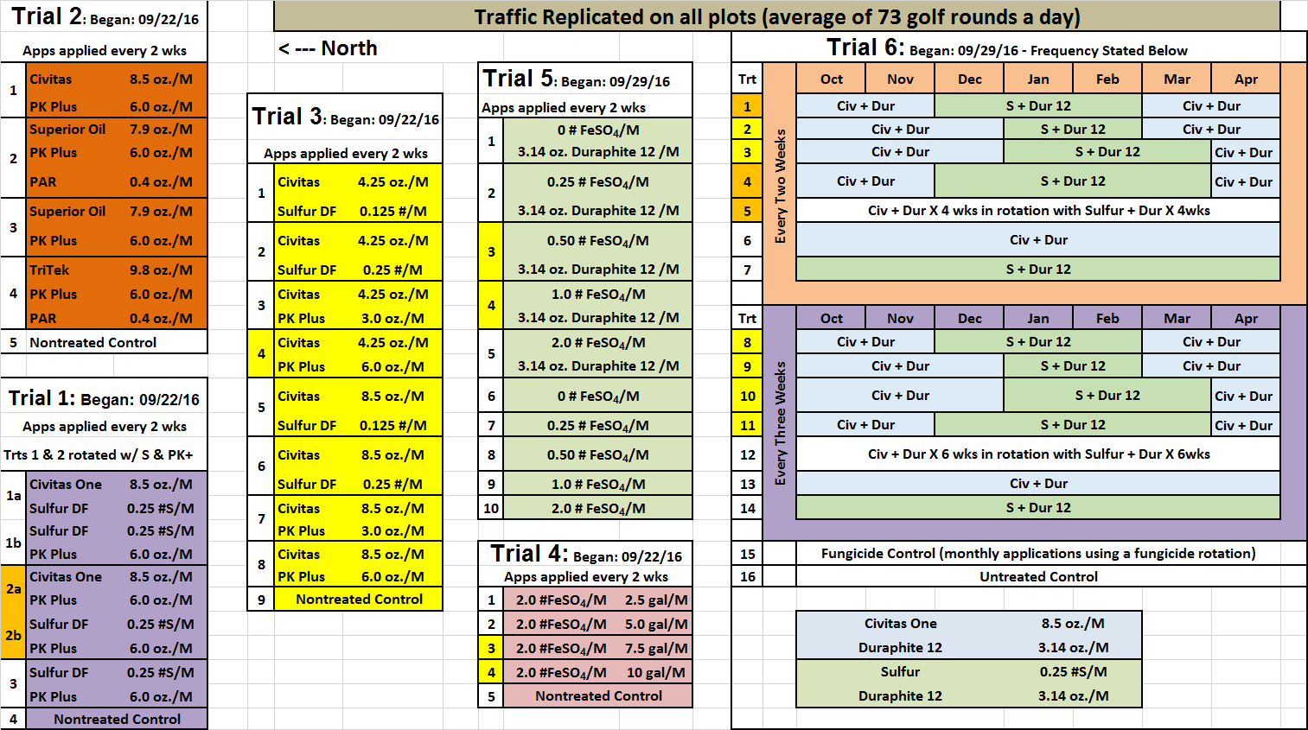
Stop 1: Clint Mattox – Fungicide Alternatives (Phosphite, Sulfur, Iron Sulfate and Crop Oil)
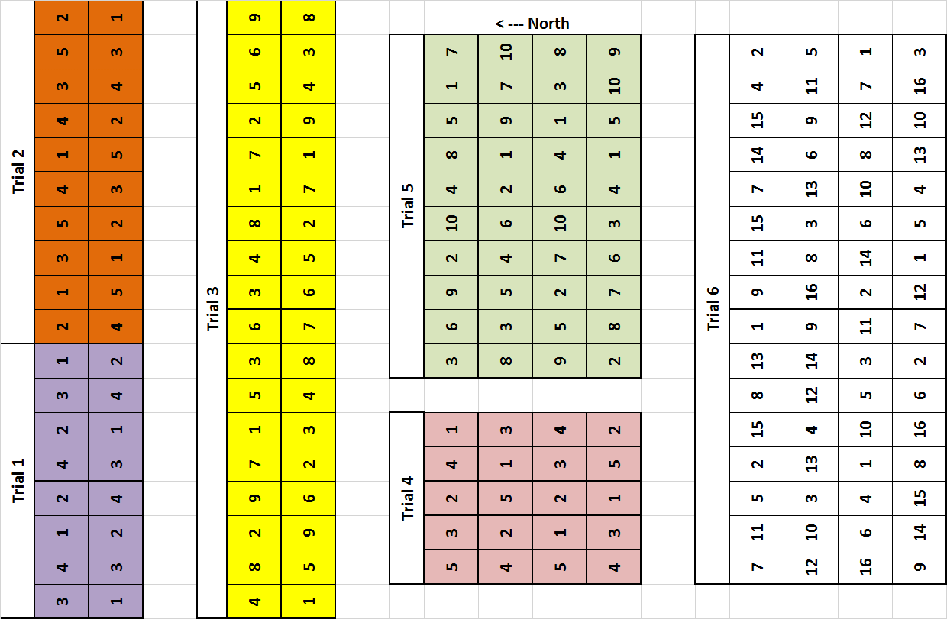
Stop 1: Clint Mattox – Fungicide Alternatives (Phosphite, Sulfur, Iron Sulfate and Crop Oil)
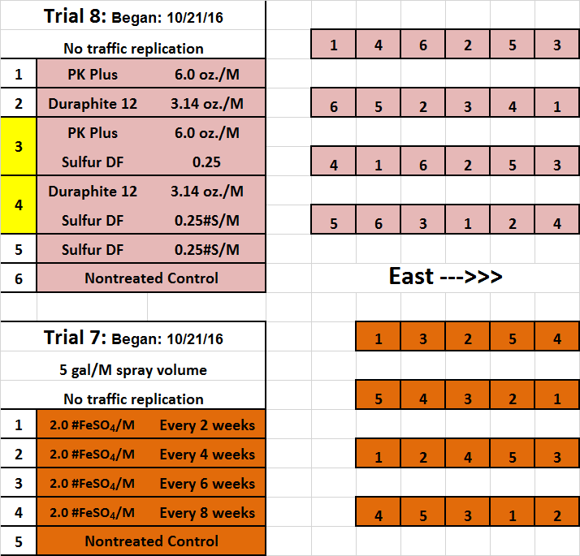

Stop 2: Conner Olsen - Effects of Greywater on Perennial Ryegrass Cultivars.

Stop 2: Conner Olsen - Effects of Greywater on perennial ryegrass cultivars.

Stop 3: Micah Gould – Low Maintenance Landscapes for Oregon Public Schools

Handouts: Plant Disease Management Report. 10:T038.

ANNUAL BLUEGRASS (Poa annua) A.R. Kowalewski, and B.W. McDonald
Microdochium patch (Microdochium nivale) Department of Horticulture
4017 ALS
Oregon State University
Corvallis, OR 97331

Evaluation of fungicides for preventative control of Microdochium patch on annual bluegrass in western Oregon, 2016.

Microdochium patch is a major turfgrass disease in cool, humid regions of the Pacific Northwest, Western Canada and Northern Europe. The objective of this study was to evaluate the efficacy of systemic fungicide applications in the DMI class and various contact fungicides for Microdochium patch control on an annual bluegrass putting green. A field experiment was initiated on 26 Jan on an annual bluegrass putting green grown on silty clay loam soil with no drainage at Oregon State University, Corvallis, OR. Experimental design was a randomized complete block, with three replications. The size of the plots measured 25 sq ft (5 ft × 5 ft). Fungicide treatments were applied on a two or four week interval, depending on labeled frequency and fungicide mode of action. Treatments were applied with a CO₂-powered, two-wheeled sprayer with a 4-ft boom using TeeJet 80015 nozzles spraying 2 gal of spray solution per 1,000 sq ft at 35 psi. Percent disease (0-100%) and turf quality (1-9 scale, with a 6 or greater considered acceptable) ratings were collected on 28 Mar, at the peak of disease. Data were subjected to analysis of variance and differences between means were determined by Fisher’s protected LSD at the 0.05 level of probability.

The untreated plots had the highest percent disease (28.3%), followed by Trinity (18.3%), and then Tourney, Torque, and Mirage (11, 7.0, and 4.3%, respectively). Secure, Turfcide 400, Daconil Weather Stik, and Dithane resulted in the lowest percent disease ranging from 0.1 to 0.4%, and had the highest turf quality ranging from 6.8 to 7.7. Banner Maxx II was the only DMI that provided acceptable turf quality with an average rating of 6.2. The untreated plots received the lowest quality ratings (2.8).

 |  |  | 28 Mar
Treatment, rate (per 1,000 sq ft) | Number of applications | Application interval^{z} | Percent disease  (0-100%)^{y} |  | Turf  quality  (1-9)^{z}
untreated |  |  | 28.3 | a | 2.8 | h
Banner Maxx II 1.3MEC 2.0 fl oz | 2 | 4 wk | 1.4 | d | 6.2 | bcd
Trinity 1.67SC 2.0 fl oz | 2 | 4 wk | 18.3 | b | 3.5 | g
Torque 3.6SC 1.1 fl oz | 2 | 4 wk | 7.0 | cd | 4.3 | efg
Mirage 2.0SC 2.0 fl oz | 2 | 4 wk | 4.3 | cd | 5.0 | def
Tourney 50WDG 0.37 oz | 2 | 4 wk | 11.0 | bc | 3.7 | fg
Secure 4.17SC 0.5 fl oz | 4 | 2 wk | 0.1 | d | 7.7 | a
Dithane 75DF Rainshield 8.0 oz | 4 | 2 wk | 0.4 | d | 6.8 | abc
Daconil Weather Stik 6F 5.0 fl oz | 1 | initial | 0.2 | d | 7.5 | ab
- Daconil Weather Stik 6F 3.6 fl oz | 3 | 2 wk
Medallion 50WP 0.5 oz | 2 | initial | 2.5 | d | 5.5 | cde
- Medallion 50WP 0.25 oz | 2 | 2 wk
Turfcide 400 4SC 8.0 fl oz | 2 | 4 wk | 0.1 | d | 7.3 | ab
^{z} Initiated 26 Jan
^{y} Mean disease severity ratings are based on a 0 to 100% scale in three replicated plots. Means followed by the same letter are not significantly different according to Fisher’s protected LSD (α=0.05).
^{x} Turf quality ratings are based on 1 – 9 scale (9 = best, 6.0 is acceptable). Means followed by the same letter are not significantly different according to Fisher’s protected LSD (α=0.05).

Handouts: Plant Disease Management Report. Volume 11, In Press (February 28, 2017)

ANNUAL BLUEGRASS (Poa annua) B.W. McDonald, and A.R. Kowalewski
Microdochium patch (Microdochium nivale) Department of Horticulture
4017 ALS
Oregon State University
Corvallis, OR 97331
Effect of fungicides on Microdochium patch in western Oregon, 2016.
The primary objective of this research was to evaluate the effects of fungicides on Microdochium patch when applied to an annual bluegrass putting green maintained at a 0.15 in. height in western Oregon. A secondary objective was to determine the number of sequential fungicide applications required to control the disease after making 2 initial applications using a scout and treat approach. Research was conducted on a native soil (Malabon silty, clay, loam) research putting green capped with a 6 in. layer of sand meeting United States Golf Association specifications at the Oregon State University Lewis-Brown Horticulture Farm in Corvallis, OR. Experimental design was a randomized complete block with four replications. The individual plot size was 6 ft by 5 ft All fungicides were applied on 25 Jan and 8 Feb, additional applications were made only when treatments were deemed unacceptable due to symptom development and reductions in turfgrass quality, but not sooner than 14 days after the last application. Fungicide treatments were applied with a CO₂-powered two-wheeled sprayer with a 4 ft boom and TeeJet 80015 nozzles spraying 2 gallons of spray solution per 1,000 ft² at 40 psi. Percent disease was assessed on a 0-100% scale, while turf quality ratings were made on a 1 to 9 scale, with 1= worst quality and 9=best. Percent disease and turf quality were collected throughout the duration of the study (25 Jan to 18 Apr) data collected at the peak of disease (4 Apr) are the only observation date presented. Data were subjected to analysis of variance and differences between means were determined by Fisher’s protected LSD at the 0.05 level of probability.
Applications of Appear, Contend A, Contend B and Banner Maxx II resulted in the lowest percent disease (0.0 to 0.2%), followed by Heritage Action (20.8%) and finally the control, which had the highest percent disease (27.5%) at the peak of disease. Regarding turf quality, Appear and Contend A provided the highest quality (7.5 and 7.4, respectively), followed by Contend B and Banner Maxx II (6.6) and finally Heritage Action and the control (3.5 and 3.0, respectively). From 25 Jan to 5 Apr Contend A was applied 3 and Contend B was applied 4 times using a scout and treat approach. Appear and Banner Maxx II were applied 5 times and Heritage Action was applied 6 times using the scout and treat application approach.
Treatments, rate per 1,000 ft^{2z} | Total applications from 25 Jan to 5 Apr | Peak of disease – 4 Apr
Treatments, rate per 1,000 ft^{2z} | Total applications from 25 Jan to 5 Apr | Percent disease  (0-100%)^{y} |  | Turf Quality  (1-9)^{x}
Appear 4.1L 6.0 fl oz | 5 | 0.0 | c | 7.5 | a
Contend A 0.86SL 1.0 fl oz | 3 | 0.1 | c | 7.4 | a
Contend B 1.66SE 2.6 fl oz | 4 | 0.2 | c | 6.6 | b
Banner Maxx II 1.3MEC 1.0 fl oz | 5 | 0.2 | c | 6.6 | b
Heritage Action 51WG 0.2 oz | 6 | 20.8 | b | 3.5 | c
Control | Not applicable | 27.5 | a | 3.0 | c

^{z} All fungicides were applied on 25 Jan and 8 Feb, additional applications were made when symptom development and reductions in turf quality were noted, but not sooner than 14 days after the last application.
^{y} Mean disease severity ratings are based on a 0 to 100% scale in four replicated plots. Means followed by the same letter are not significantly different according to Fisher’s protected LSD (α=0.05).
^{x} Turf quality ratings are based on 1 – 9 scale (9 = best, 6.0 is acceptable). Means followed by the same letter are not significantly different according to Fisher’s protected LSD (α=0.05).

Handouts: Plant Disease Management Report 10:T039.

ANNUAL BLUEGRASS (Poa annua) B.W. McDonald and A.R. Kowalewski
Anthracnose (Colletotrichum cereal) 4147
Department of Horticulture
Oregon State University
Corvallis, OR 97331

Evaluation of fungicide programs for the control of anthracnose on annual bluegrass in western Oregon, 2015.

The objective of this study was to evaluate the efficacy of fungicide programs (repeated applications and rotations of various products) for the control of anthracnose on an annual bluegrass putting green. A field experiment was conducted at the OSU Lewis-Brown Horticulture Farm in Corvallis, OR. The research was initiated on Jun 15 on a putting green built in 2009 using the California construction technique consisting of sand-based annual bluegrass sod (Bos Sod, Canada). Experimental design was a randomized complete block, with four replications, and individual plots were 25 sq ft (5 ft by 5 ft). Fungicide treatments were applied biweekly (except Signature Xtra at 2.0 oz + Daconil Ultrex at 3.2 oz, which was applied weekly) using a CO₂-powered two-wheeled sprayer with a 4 ft boom using TeeJet 80015 nozzles spraying 2 gal of spray solution per 1,000 sq ft at 35 psi. Percent disease (0 to 100%) and turf quality (1 to 9 scale; 6 or greater considered acceptable) were collected bi-weekly from 15 Jun to 8 Sep, with the peak of disease occurring on 24 Aug. Data were subjected to analysis of variance and mean separated using Fisher’s protected least significant difference (LSD) at a 0.05 level of probability.

All fungicide treatments and rotations reduced percent disease in comparison to the control. Percent disease within plots treated with fungicides ranged from 0.0 to 0.4%, while the control plots averaged 9.5%. Nine of the thirteen fungicide treatments provided turf quality ratings which ranked in the top category (7.5 to 8.4, on a 1-9 scale). The exceptions were Signature Xtra (4.0 oz per 1,000 sq. ft.) + Daconil Ultrex, Signature applied alone, and Daconil Weather Stik + Signature, which received a rating ranging from 7.3 to 7.4. The control produced the lowest turf quality (4.3).

 | 24 Aug
Treatments and rate (per 1,000 sq ft)^{z} | Percent disease  (0-100%)^{y} |  | Turf quality  (1-9)^{x}
Untreated | 9.5 | a^{w} | 4.3 | d
Signature Xtra 60WDG 2.0 oz + Daconil Ultrex 82.5WDG 3.2 oz | 0.0 | b | 8.4 | a
Signature Xtra 60WDG 4.0 oz + Daconil Ultrex 82.5WDG 3.2 oz | 0.4 | b | 7.4 | bc
Signature Xtra 60WDG 6.0 oz + Daconil Ultrex 82.5WDG 3.2 oz | 0.0 | b | 8.3 | ab
Signature 80WDG 4.0 oz + Daconil Ultrex 82.5 WDG 3.2 oz | 0.4 | b | 7.5 | abc
Signature 80WDG 4.0 oz | 0.3 | b | 7.3 | c
Mirage 2.0SC 1.0 fl oz  - rotated w/ Signature Xtra 60WDG 4.0 oz + Daconil Ultrex 82.5 WDG 3.2 oz | 0.0 | b | 8.1 | abc
Daconil Action 6.112SC 3.5 fl oz + Appear 4.1L 6.0 fl oz + Primo MAXX 1ME 0.1 fl oz  - rotated w/ Heritage Action 50WG 0.2 oz + Primo MAXX 1ME 0.1 fl oz | 0.0 | b | 8.3 | ab
Daconil Action 6.112SC 3.5 fl oz + Appear 4.1L 6.0 fl oz + Primo MAXX 1ME 0.1 fl oz | 0.2 | b | 8.0 | abc
Daconil Weather Stik 6SC 3.6 fl oz + Signature 80WDG 4.0 oz | 0.3 | b | 7.3 | c
Daconil Action 6.112SC 3.5 fl oz + Appear 4.1L 6.0 fl oz + Primo MAXX 1ME 0.1 fl oz  - rotated w/ Velista 50WG 0.5 oz + Appear 4.1L 6.0 fl oz + Primo MAXX 1ME 0.1 fl oz | 0.0 | b | 8.1 | abc
Daconil Action 6.112SC 3.5 fl oz + Heritage Action 50WG 0.5 oz + Appear 4.1L 6.0 fl oz | 0.1 | b | 7.8 | abc
Insignia 2.08SC0.4 fl oz + Daconil Weather Stik 6F 3.6 fl oz | 0.0 | b | 7.5 | abc
^{z} All treatments were applied every 2 weeks except for the mix of Signature Xtra (2.0 oz) + Daconil Ultrex (3.2 oz) which was applied weekly.
^{y} Mean percent disease ratings are based on a 0 to 100% scale in four replicated plots.
^{x} Turf quality ratings are based on 1 to 9 scale (9 = best, 6.0 is acceptable).
^{w} Means followed by the same letter are not significantly different according to Fishers’ protected LSD (α=0.05).

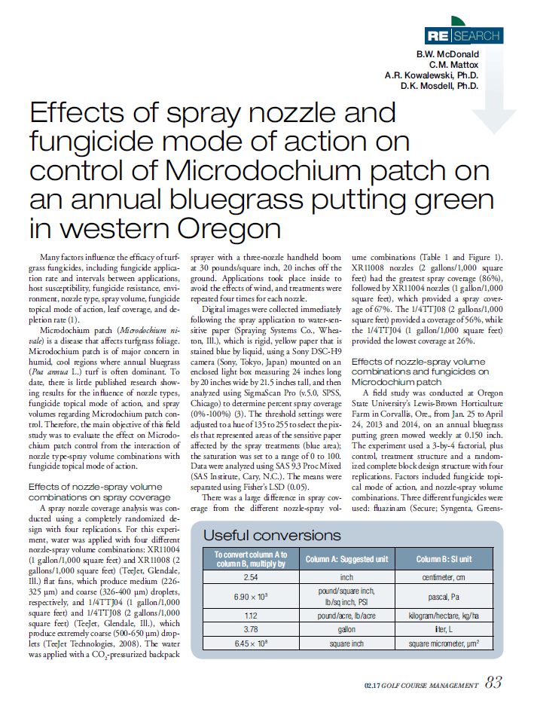

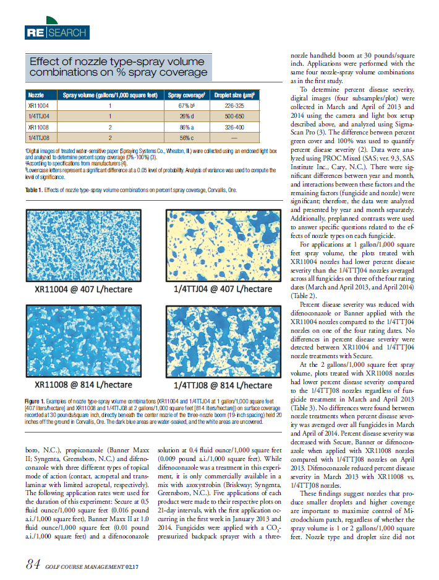
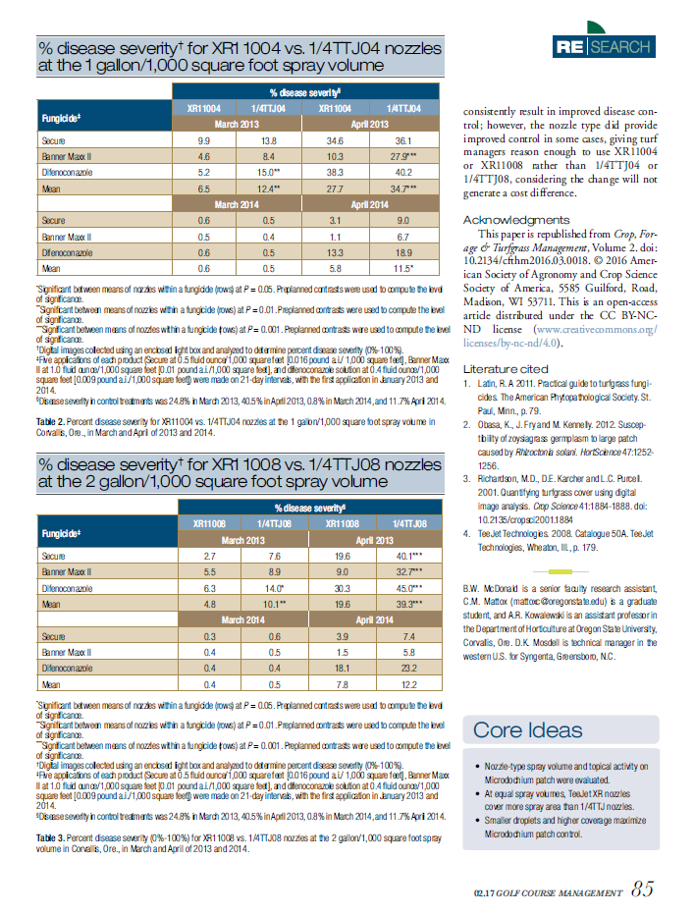
OSU Turf Technician Reports (2014 to Present)

In 2014, Brian McDonald was awarded the industry funded OSU Turf Technician position ($75,000 per year) provided by the following donors: Oregon Turfgrass Foundation, Oregon Golf Course Superintendents Association, Oregon Golf Association (for a combined $50,000 annually), Bandon Dunes Resort ($10,000 annually), Turf Merchants, Inc. ($10,000 annually), and Pure Seed Testing, Inc. ($5,000 annually). The OSU Turf Program would like to thank these generous donors by documenting the progress achieved by the OSU Turf Technician since 2014 with the following report.
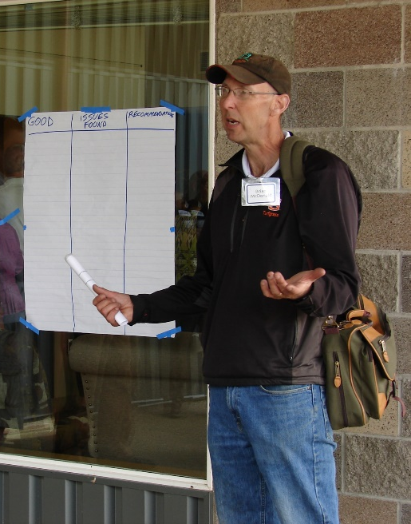
Extension and Outreach (2014 to present):
- Stakeholders Reached: 3,375
- Presentations: 23

Brian is an active member of the OSU Turf Extension program regularly speaking to stakeholder group such as the golf course employees, pesticide applicators, public school grounds employees, and parks and recreation department employees.

Scholarship (2014 to present):
- Scientific Presentations: 11
- International Presentations: 9
- Peer Review Publications: 14
Brian McDonald provides extension information to Oregon public school grounds employees in Salem, OR
- Scientific Abstracts: 9
- Proceedings and Popular Press Articles: 28

Brian has been, and continues to be, a critical component to the scholastic achievements within the OSU Turf Program. He has served as an author and coauthor for scientific and industry publications and presentation on a state, regional, nation and international level.

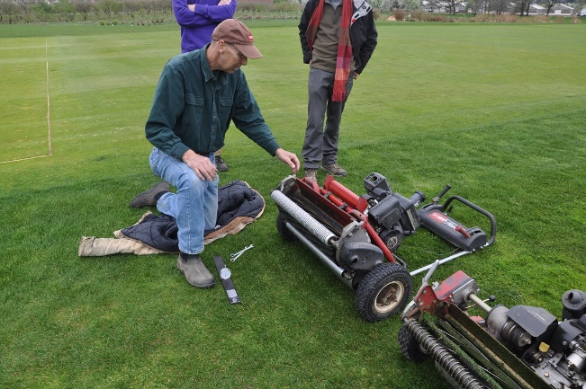
Course Laboratory Technician (2014 to present):
- Principles of Turfgrass Maintenance (HORT 314)
- Grounds Irrigation (HORT 360)
- Pesticide Applicator Training (HORT 405)
- Golf Course Maintenance (HORT 418)

Brian regularly serves as a teaching assistant for the courses listed above. Teaching responsibilities include, but are not limited to, equipment calibration and training, weekly budgeting laboratories, plant and weed identification, lectures on fungicides, herbicides and nozzle selection.
Brian McDonald teaches undergraduate student how to set the mowing height on a greens mower in Corvallis, OR.

Notable Research Projects (2014 to present):
Brian McDonald has been heavily involved in the following competitive grants listed below (1-8). He has drafted proposals, maintained plots, applied treatments, collected and analyzed data, and drafted reports for these projects. Brian has also been responsible for another 60 industry funded projects (not shown), which include, but are not limited to fertilizer, fungicide, herbicide, and wetting agent development and assessment.

1: Fungicide Alternative Management Practices for Microdochium Patch
Objective: Evaluate the Effects of Alternatives to Traditional Fungicides (such as rolling, fertility, crop oil, pigments, and wetting agents) for Control of the Microdochium patch
Funding Sources: Golf Course Superintendents Association of America (GCSAA), Oregon Golf Course Superintendents Association (OGCSA), Northwest Turf Association (NTA), and Western Canada Turf Association (WCTA).

2: The Effects of Mowing Delay on Proxy Efficacy for Poa annua Seed Head Suppression
Objective: Determine if mowing delays prior to and following the application of Proxy will affect the seed head suppression of annual bluegrass during the spring flush
Funding Source: United States Golf Association (USGA)

3: Effects of Sulfur, Calcium Source, and pH on Microdochium Patch
Objective: Determine if sulfur applied with and without various calcium sources can reduce the number of annual fungicide applications necessary to manage Microdochium patch
Funding Source: United States Golf Association (USGA)

5: Winter Foot Traffic
Objective: Evaluate the effects of winter foot traffic rates on an annual bluegrass putting green in Corvallis, OR.
Funding Source: United States Golf Association (USGA)

6: National Low Input Cool-Season Trial
Objective: Evaluate the seasonal tolerance and quality of various cool-season turfgrass genus and species with minimal inputs (monthly mowing, and no irrigation or fertilization).
Funding Source: National Turfgrass Evaluation Program (NTEP)

7: National Fine Fescue Traffic Trial
Objective: Evaluate the traffic tolerance of commercially available and experimental fine fescue (creeping, chewings, sheep, slender and hard fescue) cultivars.
Funding Source: National Turfgrass Evaluation Program (NTEP)

8: National Perennial Ryegrass Trial
Objective: Evaluate the health and quality of commercially available and experimental perennial ryegrass cultivars.
Funding Source: National Turfgrass Evaluation Program (NTEP)

