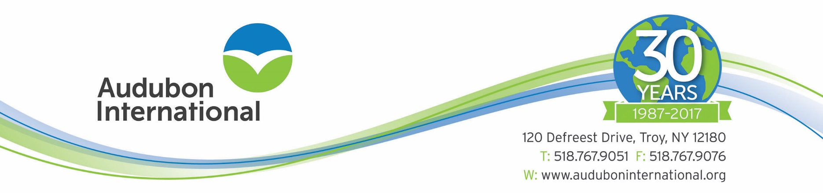

FOR IMMEDIATE RELEASE- February 2017
CONTACT: Allie Smith, Program Specialist
(518) 767-9051, Ext. 116
allie@auduboninternational.org

Heron Lakes Golf Course Recognized for Environmental Excellence

PORTLAND, OR – Heron Lakes Golf Course has retained its designation as a "Certified Audubon Cooperative Sanctuary" through the Audubon Cooperative Sanctuary Program for Golf Courses, an Audubon International program. Jesse Goodling, Golf Course Superintendent, led the effort to maintain sanctuary status on this course. Heron Lakes Golf Course was designated as a Certified Audubon Cooperative Sanctuary in 1996 and is one of 896 courses in the world to currently be designated as such.

The Audubon Cooperative Sanctuary Program for Golf Courses, endorsed by the United States Golf Association, provides information and guidance to help golf courses preserve and enhance wildlife habitat, and protect natural resources. Golf courses from the United States, Africa, Australia, Canada, Central America, Europe, Mexico, and Southeast Asia have achieved certification in the program.

"Heron Lakes Golf Course has shown a strong commitment to its environmental program. They are to be commended for preserving the natural heritage of the area by protecting the local watershed and providing a sanctuary for wildlife on the golf course property," said Tara Donadio, Director of Cooperative Sanctuary Programs at Audubon International.

"To reach certification, a course must demonstrate that they are maintaining a high degree of environmental quality in a number of areas," explained Donadio. These categories include: Environmental Planning, Wildlife & Habitat Management, Outreach and Education, Chemical Use Reduction and Safety, Water Conservation, and Water Quality Management. Courses go through a recertification process every three years.

Audubon International is a 501(c)(3) nonprofit organization based in Troy, NY. In addition to golf courses, Audubon International also provides programs for businesses, schools, communities, and new developments with the purpose of delivering high-quality environmental education and facilitating the sustainable management of natural resources. For more information, call Audubon International at 1-844-767-9051 or visit www.auduboninternational.org.
####

