Title:
Corporate Social Responsibility & How Golf Plays a Role in the Green Sports Movement

Abstract:
The golf industry is dedicated to preserving the environment through best practices in golf course management, natural resource management, and finding innovative solutions to changing climates. The green sports movement can be utilized as a catalyst for local and global impact, and golf has the opportunity to collaborate on the great work being done.

The goal of the presentation is to share examples of how sustainability, Corporate Social Responsibility, and the broader green sports movement are impacting business as usual. The presentation will showcase examples on how the Oregon GCSAA can play a role in advancing the message of environmental, social, and economic stewardship.

- General knowledge about Corporate Social Responsibility and how it pertains to golf, including: GRI, SDG’s, and State Climate Plans
- Examples on how to integrate environmental, social, and economic value using examples
- Green Sports Alliance and the broader green sports movement

Speakers:

Aubrey McCormick, VP of Business Strategy

Aubrey is VP of Business Strategy at Sustainable Business Consulting (SBC), a BCorp voted Best for The World, serving clients in 38 industries with 115 clients including REI, Nordstrom, Amazon, Alaska Airlines, and City of Seattle to name a few.

Aubrey is a former professional golfer with over 10 years of experience, ranging from public and private club operations, television, instruction, and was featured as the First Green Golfer on NBC Golf Channel's Big Break television show. Named “Golf’s Voice of Reason,” by TurfNet magazine, Aubrey is co-author of the Mauna Kea Golf Course Sustainability Case Study and Olympic Club Corporate Social Responsibility report, the first in the history of golf.

Aubrey holds an MBA in Sustainable Management from Presidio Graduate School, a program ranked #1 by the New York Times for students who want to "Change the World." She is an Accredited LEED professional, Climate Change Planning professional, Women's task force member of the World Golf Foundation, and Advisory board member for Renewable Now TV network.
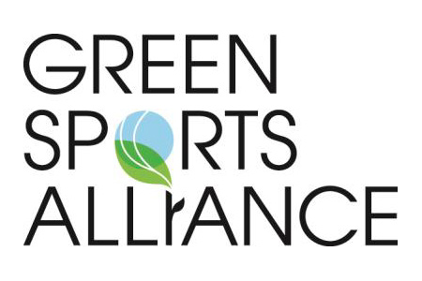

Erik Distler, Director of Partnerships

Erik is the Director of Partnerships at the Green Sports Alliance with responsibility for leading and overseeing external strategic partnerships, sponsorships and membership, in addition to leading the Alliance's collaboration with ESPN as an environmental and strategic corporate social responsibility advisor.

Before joining the Alliance, Erik was a management consultant within the Sustainable Business Solutions practice at PwC, with prior professional experience predominantly within business development, accounting and finance.

Erik holds of Masters of Public Administration (MPA) in Sustainable Management from Presidio Graduate School and an undergraduate degree from Iowa State University with Honors & High Distinction in Accounting and Finance.

